Retail Product Data and Customer Transaction Data

Dataset:

- Transaction.csv dataset linked here
- Product.csv dataset linked here

Introduction
Data analysis has become a crucial component that positively impacts companies around the world encompassing the collection of data, testing processes, and the analysis of results. From preparing, cleaning , training to modelling and analysing. Companies strive to maintain accurate data and a wide range of information that can support and benefit their operations and decision-making processes. One of the main features used in machine learning is the recommendation system. A recommender system suggests different items that are relevant to the user’s interests and preferences. Recommendation systems are now commonly used in various projects due to their significance in supporting decision-making and providing detailed information about products or services (Ramzan et al., 2019). Nowadays, e-commerce is considered to be strongly connected to customer satisfaction, and its ultimate success largely depends on customer loyalty (Ramzan et al., 2019).
This assignment evaluates an online retail business dataset and examines recommendation systems through the analysis and comparison of different machine learning models. It also includes market basket analysis using the Apriori and FP-Growth algorithms to identify purchasing patterns and customer behaviour. Finally, a well-designed dashboard was developed specifically for adults aged over 65 to clearly summarise the key insights and important factors within the dataset.
This dataset contains household level transactions over two years from a group of 2,500 households who are frequent shoppers at a retailer. It contains all of each household’s purchases, not just those from a limited number of categories. For certain households, demographic information as well as direct marketing contact history are included.

Recommendation system
Recommendation system usually offer several advantages for businesses and customer .It helps users save time by recommending relevant choices and and discover new options. For instance, on some websites, products such as movies, homeware, books, and clothing are often purchased sequentially. For businesses, recommendation systems increase customer engagement, improve customer retention, and, most importantly, boost sales. It helps predict and suggest what customers are likely to buy next. New items within the website (eg seasonal items ) also require an explore–exploit process, allowing products that have not yet had many purchasing opportunities to still be recommended and given visibility to customers (Smith and Linden, 2017). In Netflix, the use of recommendation systems has become highly significant and has positively impacted the platform by improving user experience and content engagement. Recommendation systems have become increasingly important on platforms such as Netflix, where they enhance the user experience by suggesting personalised content based on viewing beqahaviour and preferences, the data collected and the resulting user experiences have shown Netflix that there are far more effective ways to help users discover videos to watch than relying solely on high predicted star ratings(Gomez-Uribe and Hunt, 2015).
Recommendation systems consist of several effective models, including Content-Based Filtering, Item–Item Based Recommendation Systems, and User–User Based Recommendation Systems.

Data Preparation
Reducing the size of both datasets was a necessary step to minimise algorithm complexity and reduce execution time. Data reduction improves the scalability and performance of the Apriori and FP-Growth algorithms, while also generating stronger and more meaningful association rules for recommendation systems. The transaction dataset contained 2,595,732 rows and 12 columns, while the product dataset contained 92,353 rows and 7 columns. A sample of the transaction dataset was selected for testing, consisting of 10,000 unique baskets. Empty baskets and unpopular products were also removed to improve data quality and model performance.
This approach allowed the recommendation system models to operate more efficiently by reducing noise, improving scalability, and generating stronger and more accurate recommendations. Using two separate datasets and merging them together was necessary, as each contained important features that complemented one another and enabled a more complete analysis. The product dataset provided detailed descriptions of each product, while the transaction dataset included information such as Basket_ID and Trans_Time.
Creating new features was an important step in improving the recommendation systems and enhancing the overall analysis. Product Text was added to provide more detailed descriptions of products, helping the system identify similarities between items. Average Basket Size per Household was created to measure the typical number of products purchased in a single transaction, giving insight into customer shopping behaviour. Household Spending was included to analyse the total amount spent by each household, while Household Purchase Frequency measured how often customers made purchases, helping to distinguish loyal and active shoppers from infrequent ones. Product Popularity was added to identify products that were commonly purchased across households, and the Interaction Score combined customer and product interaction data to measure the strength of the relationship between households and products.

Content-Based Filtering
A content-based filtering system recommends items by analysing the relationship between the characteristics of the items and the user’s preferences (Van Meteren and Van Someren, 2000) and it recommends similar characteristics to the original products.
The original item was tested is a private-brand granola bar within the “Convenient Breakfast/Wholesome Snacks” category. All recommended products also belonged to the same commodity and sub-category. This simply shows that the model is effective and successfully matched the original product to relevant recommendations use which is one of the main advantage. One disadvantage is it might recommend too relevant product which reducing product diversity limit chances to users to discover new items outside their preferences.

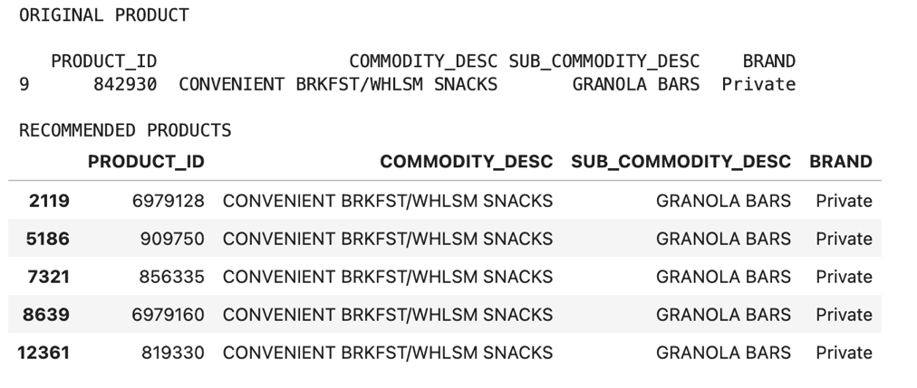

Item-Item Based Recommendation
Item–Item Based Recommendation focuses on recommending products by identifying similarities between items that users commonly purchase, as it compares products directly with one another.
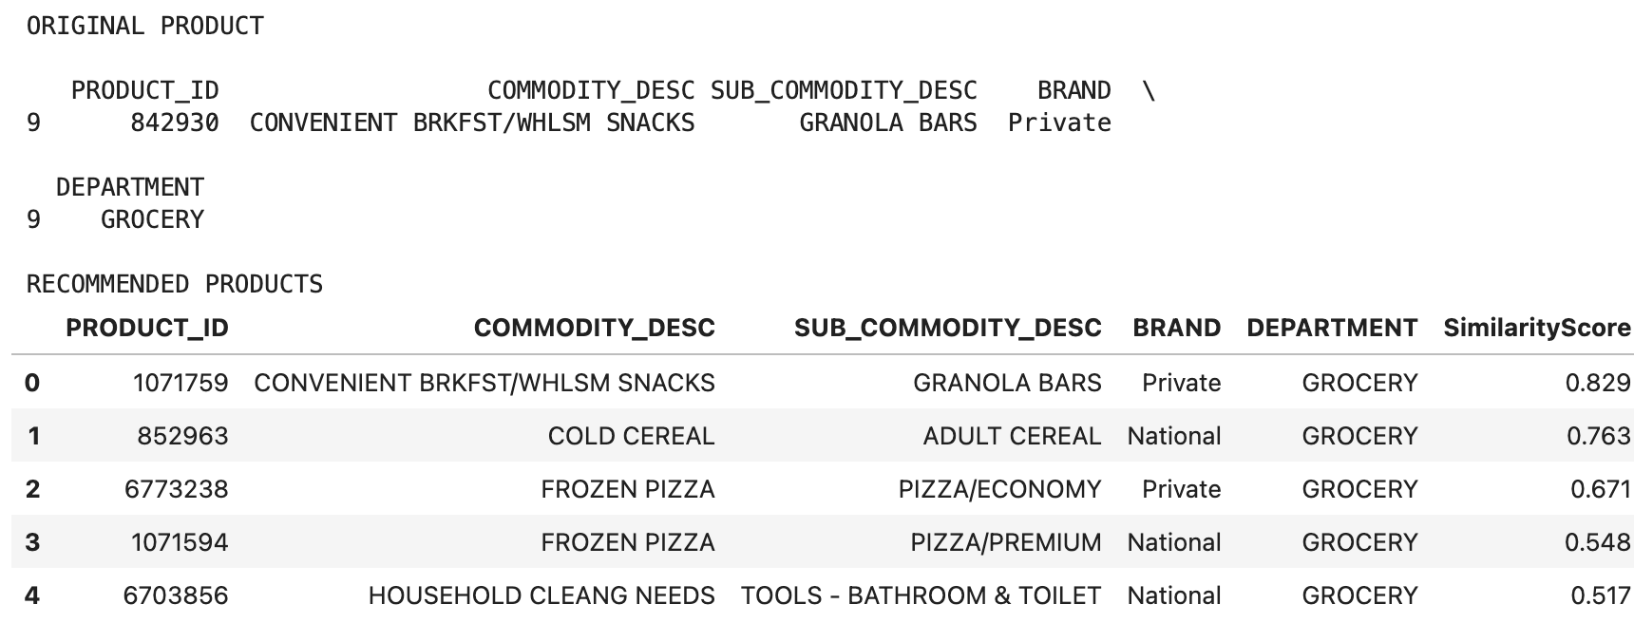

It is clear from the table above that the item-item collaborative filtering recommender system is functioning effectively and generating meaningful product recommendations based on customer purchasing behaviour. The item-item collaborative filtering demonstrate a strong relationship between products in the table. Based on the similarity score, it suggests how often products are purchased by similar households. As the original product is Granola Bars, there is a high likelihood that a household will purchase the same product again due to the strong relationship score between the two products (0.829). Bathroom cleaning products has a Medium relationship with a (0.517) with the original product compared to higher similarities.
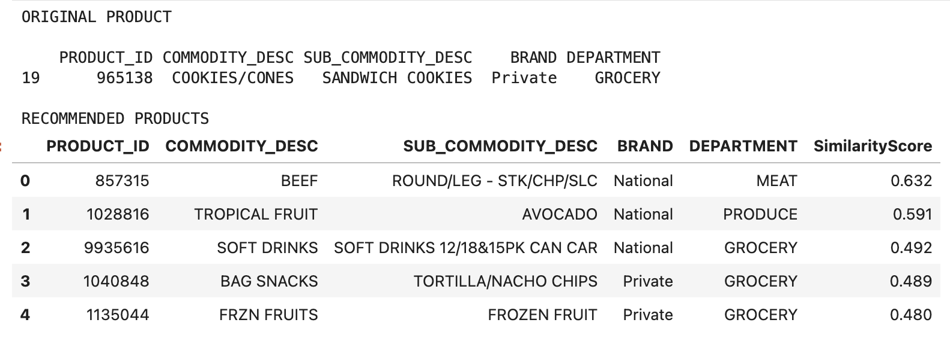
This table show the relationship or similarity of the original product (sandwich cookies) with five other products. The most similar product was Beef with a Similarity Score of (0.632), followed by Avocado (0.591), Soft Drinks (0.492), Tortilla/Nacho Chips (0.489), and Frozen Fruit (0.480). The recommendation system suggest who buys sandwich cookie often buy beef and other products from different variety

User-User Based Recommendation system

A form of collaborative filtering known as a User-User Based Recommendation System makes product recommendations to customers based on the tastes and purchasing patterns of other customers who share their interests. Users with comparable purchasing histories and buying habits are first identified by the algorithm. Next, it suggests items that the target user hasn't yet purchased but that comparable people have. This strategy works well because it makes use of the collective behaviour of customers instead of depending on the features of the product.

In this example, Household 2375 has a more variety of fresh produce and healthier food choices as the system includes Value Added Fruit, Salad Bar Fresh Fruit, Pourable Salad Dressings, Potatoes, and Juice. This shows that household with similar interest usually purchase fresh fruits, vegetables, and complementary grocery products. The system has successfully identified a customer segment focused on fresh and nutritious foods.

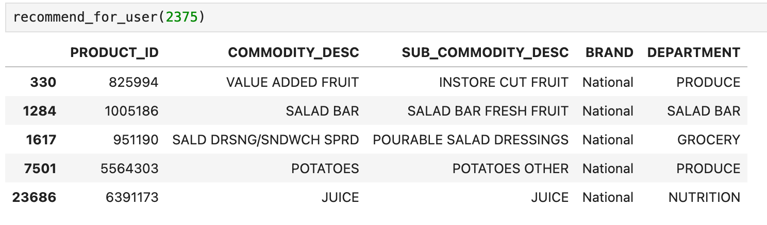
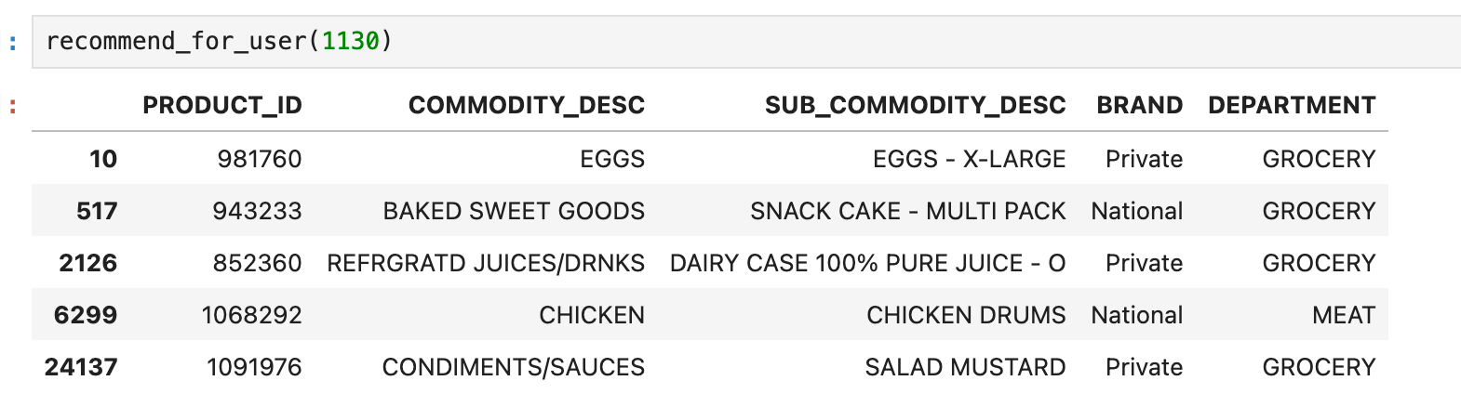

Household 1130, the User–User Based Recommendation System recommended Eggs, Snack Cakes, 100% Pure Juice, Chicken Drums, and Salad Mustard. It is clear that these recommendation are a combination of staple grocery products, meal ingredients, and snack items that are commonly purchased by households with similar shopping behaviours. While snack cakes and juice show complementary food and beverage purchases, eggs, chicken, and mustard suggest that similar households regularly purchase ingredients used for meal preparation, suggesting that the recommendations are still relevant.

Overall, the content based filtering recommends products based on their characteristics and descriptions. While The Item–Item Based Recommendation System focuses on relationships between products by analysing purchasing patterns, higher similarity scores and user recommendations are given to products that are commonly bought together. and the User–User Based Recommendation System takes a different approach by analysing similarities between households where clients with similar shopping habits were identified using variables including Household Spending, Purchase Frequency, Average Basket Size, and Interaction Score.

Overall, the results from all three models demonstrate their effectiveness in generating relevant recommendations, with many recommendations achieving relatively high similarity scores. This indicates that the models were successful in identifying meaningful relationships between products and customer purchasing behaviours. However, each model demonstrated different strengths. The Content-Based Filtering model generated the most product-focused recommendations by identifying items with similar characteristics, the Item–Item model was particularly effective at recommending complementary products that are frequently purchased together, and the User–User model provided the highest level of personalisation by leveraging the purchasing behaviour of similar customers.

Apriori / FP-Growth

Finding frequently purchased product combinations and comparing the effectiveness of the two algorithms are the goals of Apriori and FP-Growth. According to the findings, both algorithms produced 280 frequently occurring itemset, demonstrating that they found precisely the same buying trends in the dataset. There was a difference in execution time.
FP-Growth was approximately 24% faster (1.4186 seconds.) than Apriori (1.8682 seconds) while producing the same number of frequent itemsets and making it a better choice for larger retail datasets..

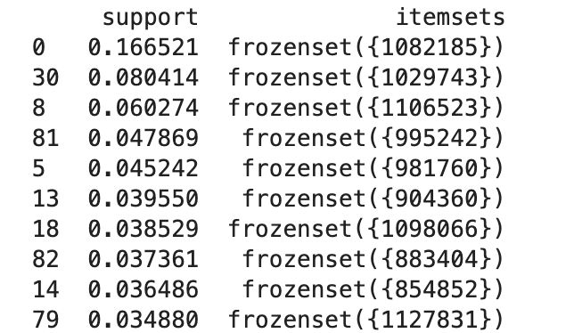

The findings show that the dataset includes a number of very well-liked products that constantly show up in consumer transactions, making them excellent candidates for more association rule mining and retail decision-making.

Data Visualisation

To provide important insights from the dataset in an understandable and approachable way, an interactive retail analytics dashboard was created. With accessibility as a top priority, the dashboard was created especially for seniors 65 and over.

By converting complicated retail data into understandable and significant visual insights, the dashboard offers a number of advantages to both users and businesses.

- Enhances Data Understanding: Without the need for manual analysis of huge datasets, the visualisations make it simpler to spot department distributions, popular products, and purchasing trends.
- Supports Decision-Making: Retail managers can utilise the data to make well-informed choices about marketing tactics, product promotions, and inventory management.
- Saves Time: Through interactive charts and summaries, users may rapidly access important insights rather than going through thousands of transaction records.
- Analyses Machine Learning Outcomes: The dashboard enables users to view recommendation model outputs and determine whether significant recommendations are being produced.
- Finding Customer Behaviour Patterns: Popular items, shopping habits, and purchase trends that might not be immediately apparent in raw data are highlighted in charts and suggestion outputs.

Product selection

The products displayed in the dashboard (Bananas, Granola Bars, Ramen Noodles, and Soft Drinks) were selected as example products to demonstrate how the recommendation system and dashboard operate. As one of the most popular supermarket items and a representation of fresh food, bananas are a good choice for evaluating consumer buying patterns. Granola bars are snack items that are often linked to purchases that are convenient and health-conscious. Ramen noodles are an example of packaged food items that are frequently bought as inexpensive, basic supermarket goods. Soft drinks are useful for evaluating consumer purchasing trends and product connections because they fall within the beverage category and are frequently bought with a wide range of food items. The dashboard can show how suggestions change across product categories by utilising products from several departments. It also helps illustrate the effectiveness of the recommendation models. The fact that these goods performed the best in the sample did not necessarily mean that they were chosen. Rather, they were selected to offer distinct and varied examples that make it simple for consumers to investigate suggestions.

Buttons explanation

In order to retain simplicity and ease of use, especially for those 65 and older, the dashboard was purposefully built with just four buttons. Applications can be made easier to use and less cognitively taxing by minimising the amount of controls.

- The Generate Recommendations button initiates the recommendation system and shows products that are commonly linked to or related to the chosen product.

- The Clear Charts button lets users begin a new analysis without having to refresh the dashboard by returning all charts and visualisations to their original state.

- Customers can select a product from the list by using the Select Product (Dropdown Menu). Recommendations are then produced using this chosen product.

- When the user has completed examining the data, the Exit button securely closes the dashboard application.
By offering a simple method of interacting with the dashboard and navigating the visualisations without the need for technical expertise, these tools enhance usability.

Charts explanation

- Bar Chart: The bar chart displays the products most frequently recommended by the recommendation system. Products are represented by the horizontal axis, while the number of suggestions made for each product is displayed on the vertical axis. According to the data, the most recommendations were for bananas, followed by soft drinks, granola bars, and ramen noodles. This implies that these products either commonly appear in recommendation outputs produced by the machine learning models, have strong associations with other products, or are regularly purchased by customers. The simple bar format makes comparisons between products straightforward and easy to interpret.

- Line Chart: Users can see how consumer demand has changed over time by looking at the line chart, which shows the quantity of products purchased each month. The months from January to June are shown by the horizontal axis (x-axis), while the total number of purchases is represented by the vertical axis (y-axis). Purchases increased steadily throughout the course of the time, from about 20 in January to 60 in June, according to the chart. This upward trend points to a gradual increase in consumer activity and product demand. Without examining a lot of raw data, the line chart's straightforward visual depiction of patterns makes it simpler to comprehend shifts in consumer behaviour.

- Pie Chart: The distribution of products among the various retail departments in the dataset is depicted in the pie chart. The size of each slice denotes its percentage of the total items, and each slice represents a department. According to the graphic, the grocery sector has the highest percentage of products (about 45%), followed by produce (25%). Departments including Drinks, Frozen Foods, and other retail categories represent smaller quantities.
The existence of several departments indicates product diversity, whereas the sizeable Grocery sector implies that the dataset is mostly focused on regular home purchases.
Users may learn which departments provide the most goods by using this visualisation, which gives an overview of the dataset composition.

Users can gain a deeper understanding of consumer behaviour, product popularity, and the retail dataset's structure by integrating these visualisations. Additionally, the three graphs aid in confirming that the dataset includes significant patterns appropriate for machine learning applications such as recommendation systems.

Reference

- Ramzan, B., Bajwa, I.S., Jamil, N., Amin, R.U., Ramzan, S., Mirza, F. and Sarwar, N. (2019). An Intelligent Data Analysis for Recommendation Systems Using Machine Learning. Scientific Programming, 2019, pp.1–20. doi:https://doi.org/10.1155/2019/5941096.
- Smith, B. and Linden, G., 2017. Two decades of recommender systems at Amazon. com. Ieee internet computing, 21(3), pp.12-18.
- Gomez-Uribe, C.A. and Hunt, N., 2015. The netflix recommender system: Algorithms, business value, and innovation. ACM Transactions on Management Information Systems (TMIS), 6(4), pp.1-19.
- Van Meteren, R. and Van Someren, M., 2000, May. Using content-based filtering for recommendation. In Proceedings of the machine learning in the new information age: MLnet/ECML2000 workshop (Vol. 30, pp. 47-56).

